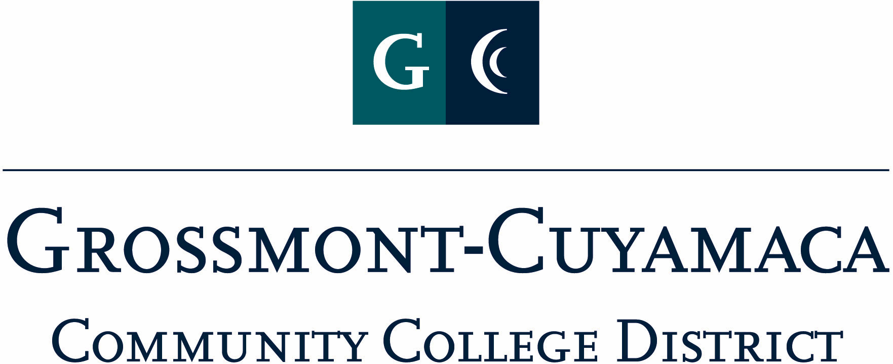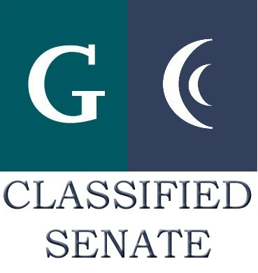
D R A F T
CLASSIFIED SENATE
EXECUTIVE BOARD MEETING
July 12, 2011–Meeting Minutes

Members Present: Wendy Corbin, Maria Briney, Debi Miller, Avelina Mitchell, Ken Grimes, Melissa Chandler, Yvette Macy, Jennine Boschock, Nicole Boyer, Pamela Wright, Joe Balestreri, Pat Murray, Glenn Macy, Rocky Rose
Members Absent: Patricia Bailey, Connie Sterling, Kari Crawford, Robert Mountain, Jean Wallace, Mary Eden, Patty Sparks
Members Excused:

1. Welcome and Call to Order: The President called the meeting to order at 12:02p. The following changes to the agenda were made: Agenda Item No.2 should indicate 6/7/11 Minutes for approval and the training should be on July 28. The Secretary conducted role call to establish quorum. Quorum was met.

2. Approval of Minutes from June 7, 2011

The minutes from June 7, 2011 meeting were approved. M/S/A Murray/Rose.

3. Continuing Business:
Mother Goose Parade. Yvette Macy reported that she had met with Chancellor Miles and discussed the prospect of district support for this event and she was enthusiastic about having the district facilitating a float at the parade. She plans to meet with the two student body presidents and discuss the prospect of working together on this event and will bring forward at the next Leadership Meeting. Ms. Corbin discussed the mother goose parade with Ms. Glasgow (GC Student Affairs Dean) and will collaborate on placing this information onto the district face book page. Ms. Corbin will continue the discussion with the Chancellor and the 2 site presidents once a theme is established, and to work on recruiting volunteers. Yvette Macy added that she hopes everyone gets involved, that the Classified Senate would have a supportive role for this year and be more student-based in the future. Ken Grimes inquired as to the fiscal support for the event. Ms. Corbin explained that last year the Classified Senate approved funds of $100 toward the event. There is no entry fee required to be in the parade. Wendy Corbin added that that a possible fundraiser might be considered to supplement the anticipated funds and perhaps consider a pancake breakfast at Applebee’s.

Assist-A-Student. Wendy Corbin added that Angela Johnson and Joe Balestreri met with Sara Glasgow, Student Affairs Dean at Grossmont College, in regards to the Assist-A-Student project and Ms. Corbin anticipates contacting Lauren Weiner, Student Affairs Dean at Cuyamaca soon on the same matter. Ms. Glasgow is proactive in putting together the face book page and welcomes the partnership with Classified Senate on this project. Ms. Corbin added that this will give the Classified Senate an opportunity to go to interclub council for the student voice and explain how they can get involved in this project.

4. Communication

VP Reports

District Services: Yvette Macy reported that they are launching the STAR award program hopefully this Thursday at FUN Thursday. It is moving along really well on that. She informed the group that the Diversity, Equity & Inclusion task force is now called a council. The group established the charge and going to be having committees from GC, CC and DS site and CC stepped up with Arleen Satele, Danene Brown & Nancy Jennings and will be looking for 2 classified staff on that committee. Include EEO representation. Investigating the hiring process, data gathering, how to share the data, investigate improvement in recruiting, etc. Culturally competency and inclusion, what can we do to have open conversation about diversity and new employee training making it mandatory? Pamela Wright is a member of the council and she added that student equity T5 requirement was in 2004 when all the colleges needed to be compliant and has not updated since then. Before next meeting District Services & Grossmont College will get their draft completed and this council will include tri-chairs (Faculty, Administrator & Classified).

Educational Master Plan. Pamela Wright shared that there is no update. They will be holding a retreat and we want to make sure we have classified representation at it. Rocky Rose asked if the classified tri-chair is up and above the other membership. The response was Yes.

Benefits: Wendy Corbin reported that the Benefits Committee is looking at fully insured programs and getting quotes, no decisions are being made and tasked with saving $500,000. You will be hearing things from your bargaining units.

Safety Committee: Meeting was cancelled.

District Executive Council (DEC): Wendy Corbin reported out from this meeting that the district is not moving forward with the Executive Vice Chancellor structure. The Chancellor will be moving forward with a Human Resource consultant (3 days a week) and Amber Hermann and Tim Corcoran will be answering to that person. Sue Rearic has been alleviated of all HR duties, but will continue to chair the District Services Leadership Council (DSL). The Chancellor did not define the level of executive for this consultant for HR.

Grossmont: Pat Murray reported that the Prop R roofing project is going on. She mentioned that the GC Choir is trying to raise money to send 30 students to Carnegie Hall. There is a Padre game the East County Chamber of Commerce is sponsoring on 8/3 at a cost of $26 per ticket and comes with hot dog, soda, etc.

Ms. Murray shared her experience from CLI. She got to meet with cool people and discussed some of the challenges that we have gone through and some that are ahead of us. Several colleges instead of having to meet once a year that we could meet once every quarter by webcam to talk about what each district is doing.

Cuyamaca: Avelina Mitchell reported that she is meeting with President Zacovic next week to discuss instituting some sort of awards program at the campus. She also shared her experience at CLI and that she had met a lot of senate members from different colleges. She received quite a few tips on awards, and other little things. It is important in doing our best in recognizing folks. Yvette Macy inquired if there was discussion on what other Senates do for their fundraisers. Joe Balestreri added that there are groups who were surprised about our fundraising that we do take in. Avelina Mitchell continued that it is important for faculty & staff come together with their unions collaborative and will continue to remain contact with these folks to bring information back to the group.

President’s Report:

Officers Handbook: the Executive Board Officers Handbooks was brought forward for final approval. Wendy Corbin called for any discussion, suggestions, etc. Motion to approve the Executive Board Officers Handbook as an official document and as-is and adjust as necessary in the future. M/S/A Rose/Mitchell. Motion passed.
E-Board Training: Wendy Corbin informed the group of the two upcoming training dates for E-Board members. On 7/21 the training will include the President, VPs, Secretary & Treasurer. The 7/28 training will be conducted for the Members-At-Large and Senators. Ms. Corbin will continue to add necessary items to calendar, and she is trying to collect important dates for the calendar, so feel free to forward any for consideration. She will send out what she has so far to all E-Boards members when she gets back to her office.

Retreat Date: The Classified Senate ½ day Retreat is set for September 16 at Mission Trails Regional Park. Wendy Corbin related that this is an important team building event and executives, Chancellor, and Board Members, etc. are invited to attend to strategize about philosophy of the Senate. Team building is important and an important role on the campuses, core resources for employees and eventually students. Whether it’s fundraising or volunteering, it is an important time dedicated away from the office. The district does offer release time for this event so we can all sit down not distracted and go over materials. The Retreat will also include time to learn about our role in the Senate and on the campus and see what our goals will be for the next 2 years. The Retreat was helpful for me when I first came in and it is my hope it will be the same for you. All together we make a strong organization. We also include a group picture of all those in attendance. The Secretary was instructed to send out Off Campus Activity Request form to all Board members.

Fall Meet & Greet Ideas: Wendy Corbin explained to the group that for the last couple of years we have held a meet & greet as an open membership meeting. This is basically our attempt at an open membership meeting to encourage people to understand who we are, so they can get involved or look to us as a resource. Assist-A-Student, Glasglow mentioned – how can we get involved all year long, what are things that the Senate could do as a resource. Mentor program was suggested. Jointly somehow we could be a resource to a student, we need to gage how many people in our Senate that may want to volunteer their time for that. What kind of time would Student have access to them, perhaps at the Meet & Greet.

Do we want to link classified senate event with the mentor program? Rocky Rose explained that at Cuyamaca College we did use a Mentor program and it was started at the very beginning of the semester with registration and each mentor was assigned to a student. Melissa Chandler mentioned that in chemistry during staff development week a program GearUp for Success was introduced to help incoming students and offered a positive way to reach out to students.

Debi Miller inquired if this would be two separate meetings, one at the beginning of semester to collaborate with Student Affair Deans at each site and another senate open meeting (Meet & Greet)?

Avelina Mitchell shared that Jesus Miranda, Counselor at Cuyamaca facilitates the First Year Experience (FYE) for students. Yvette Macy added that she is open to anything that will bring more people into M&G and have her support. Wendy Corbin would like to draw more folks to the senate open meeting. She asked if perhaps the senate should consider doing targeted events. This is a time for people to be heard and share ideas that are widespread throughout the district. The main purpose of the fall meet & greet is to brainstorm about CSAD themes and the facilitating and organizing for that particular day.

Rocky Rose suggested that the senate consider a Mentor program event separate from the Meet & Greet. The group continued to discuss this proposal. The group thought it would be too soon to try and facilitate the mentor program for Fall, but would like to discuss in more depth at the Retreat. Motion to include the Student Mentor Program as a discussion item for the Fall Retreat. M/S/A Mitchell/Macy. Motion passed.

Treasurer Report: Maria Briney reported that she is working with Paula Tillery (former Treasurer) on transition and will pulled reports for next meeting.

5. Fundraising Activities: Wendy Corbin explained that current the Classified Senate conducts fundraising with See’s, and Dudley’s. She asked the group if they had any other ideas. Yvette Macy asked if there is something that we need to raise money for. Wendy Corbin mentioned possible having a fundraiser for the Assist- A-Student and schedule an event to celebrate the mentorship at the end of the year.

Due to time restraints of the meeting, Ms. Corbin asked the Board to e-Mail your suggestions to her. She will also be formulating and forwarding to you on committees that are point of interest. Bring back to next meeting.

6. Governance: Nothing brought forward.

7. New Business:

Assist-A-Student: Volunteers needed. If you are interested please contact Angela Johnson.

Beach Picnic: Wendy Corbin would like to plan this. The gathering as a point of camaraderie for the district. Easy access for most turnout. Bring back to next meeting.

Good of the Order:
Motion $67.25 the fundraising profits of 10% for students to the GC Gospel Choir traveling to Carnegie Hall. M/S/A Macy/Boyer. Motion passed.

The meeting adjourned at 1:05p.

